OFFICIAL CALL
LEGISLATIVE DISTRICT PARTY CANVASS
OF THE 28TH SENATE DISTRICT
OF THE REPUBLICAN PARTY OF VIRGINIA

As Chairman of the 28th Senate District Committee of the Republican Party of Virginia (“Committee”), and pursuant to the Plan of Organization of the Republican Party of Virginia as amended December 3, 2021 and as recommended and directed by the Committee, I, David E. Willis, do, on this 7th Day of March, 2023, hereby issue this call for a Legislative District Party Canvass to be held at three balloting stations.

For voters who are residents of Fauquier and Rappahannock Counties:
Grace Miller Elementary School
6248 Catlett Road
Bealeton, VA 22712

For voters who are residents of Culpeper, Madison and Greene Counties:
Reformation Lutheran Church
601 Madison Rd
Culpeper, VA 22701

and

For voters who are residents of Orange and Spotsylvania Counties:
Unionville Elementary School
10285 Zachary Taylor Hwy
Unionville, VA 22567-2422

The Canvass will be held from 10:00 a.m. through 4:00 p.m. local time on Saturday, May 6, 2023 for the purposes of nominating a Republican candidate for the office of Senator to be voted for in the General Election on November 7, 2023.

Qualifications For Participation

All legal and qualified voters of the 28th Senate District under the laws of the Commonwealth of Virginia, regardless of race, religion, national origin or sex, who are in accord with the principles of the Republican Party and who, if requested, express in open meeting either orally or in writing as may be required, their intent to support all of its nominees for public office in the ensuing election, may participate as members of the Republican Party of Virginia in its mass meetings, party canvasses, conventions or primaries encompassing their respective election districts.

In addition to the foregoing, to be in accord with the principles of the Republican Party, a person otherwise qualified hereunder shall not have participated in Virginia in the nomination process of a party other than the Republican Party with in the last five years. A single exception shall be approved for a voter who renounces affiliation with any other party in writing, and who expresses in writing that he or she is in accord with the principles of the Republican Party and intends to support the nominees of the Republican Party in the future. A voter who utilizes the foregoing exception, and thereafter participates in the nomination process of a party other than the Republican Party, shall not have the benefit of the exception identified in this paragraph thereafter. The 28th Senate District Committee will provide a copy of all signed renunciation statements to the Republican Party of Virginia, to be maintained for a period of five years.

Any voter who, subsequent to making a statement of intent, publicly supports a candidate in opposition to a Republican nominee is not qualified to participate as a member of the Republican Party of Virginia in its mass meetings, party canvasses, or conventions for a period of four (4) years.

Balloting

Balloting will begin at 10:00 a.m. and will end at 4:00 p.m., except that anyone in the registration line at 4:00 p.m. may continue the registration process.

In order to receive a ballot, the voter must:
- Present a valid, non-expired photo identification issued by the Commonwealth of Virginia, one of its political subdivisions, or the United States government.
- Appear in the poll book (using data from GOP-Data. If the voter’s name does not appear in the GOP-Data poll book, a voter identification card issued by the Commonwealth of Virginia or the voter’s Registrar clearly identifying the voter as a resident of Senate District 28 may be presented by the voter. (Cards were issued to all voters by mail by the Department of Elections. Replacements can be received from the voter’s Registrar or online at the Virginia Voter Information – Citizen Portal (https://vote.elections.virginia.gov/VoterInformation/Lookup/status)) The last option for verifying the voter’s status would be to have the voter log into the Citizen Portal o show the Credentials Committee representative at the polling location that they are properly voting in the firehouse primary.
- A Declaration of Voter Qualification (Attached), properly completed and signed by the voter, must be submitted at the time of registration. No ballot will be given to any voter who has not signed and submitted this Declaration of Voter Qualification.

No absentee voting, proxies, or provisional ballots are permitted.

No registration fees are required for voting in this party canvass.

Votes will be counted only for those candidates whose names appear on the official ballot. No write-in votes will be permitted. Any ballot with more than one candidate name marked will be declared invalid.

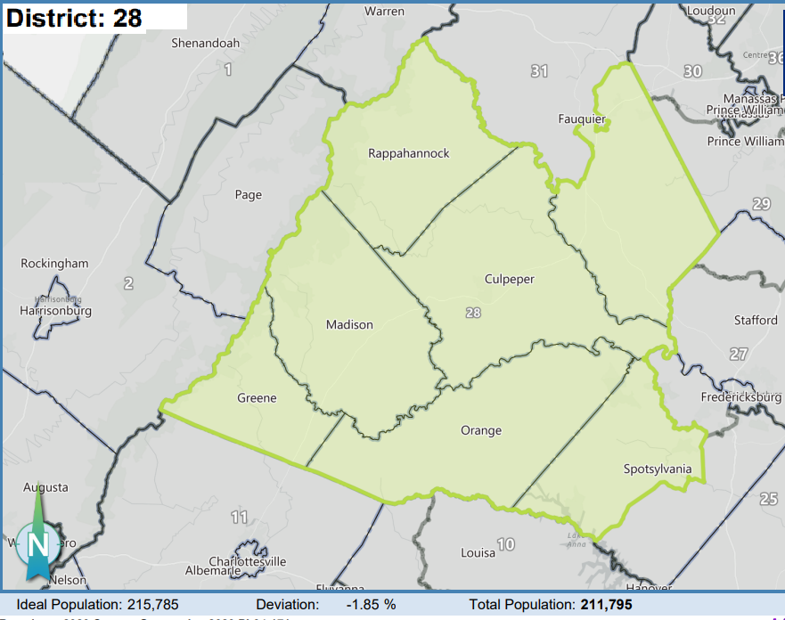

Candidate Filing Requirements

Any person seeking election as the 28th District Republican Nominee for Senate at said canvass shall file a written statement and the below required documents by mail or in person, to:
David E. Willis, Chairman
28th Senate District Republican Committee
4214 Mount Ephraim Road
Sumerduck, VA 22742
(571) 334-2182
david.e.willis@reagan.com

The required documents must be received not later than 5:00 p.m. on March 14, 2023 (postmarks do not control).

The required documents are:
- A check in the amount of $720 (the allowed two times the filing fee for a Senate primary) payable to the “Spotsylvania Republican Committee” for the 28th Senate District Committee of the Republican Party of Virginia;
- A completed Declaration of Candidacy;
- A completed Certificate of Candidate Qualification for the Senate; and
- A completed Statement of Economic Interests.

Incomplete or modified filing forms, and/or filing forms accompanied by an invalid check, will be returned, and the individual will be deemed to have not filed for candidacy. Chairman Willis can be contacted at (571) 334-2182 or david.e.willis@reagan.com.

If not more than one person properly files for candidacy and is determined to be qualified, then that person is deemed to be nominated and the canvass will not be held.

Credentials Committee

Chairman of the Credentials Committee is to be appointed by the Chairman of the 28th Senate District Committee. The committee will include the Chairman of each voting site as appointed by the 28th Senate District Committee Chairman. The Credentials Committee Chairman may appoint additional members of the committee at his own discretion. The committee will meet prior to the canvass on the call of the appointed chairman.

The Credentials Committee will be governed by and conducted in accordance with (to the extent possible and giving precedence as listed), State Election Laws and Regulations, the Republican Party of Virginia Plan of Organization (the “Party Plan”), these official rules of the Canvass, and Roberts Rules of Order, 12th Edition.

The duties of the Credentials Committee include:
- Ascertaining and reporting to the Chairman of the 28th District Senate Committee Chairman the adequacy of the documents filed by candidates for nomination no later than 5:00 p.m. on Saturday, March 18, 2023;
- Establishing a ballot tally form to be used by the Site Chairmen and establishing the procedures to be employed in gathering ballots and tabulating the results in the three voting sites and then compiling the vote for the 28th Senate District to determine the nominee;
- Resolving any Credentialing issue from the voting sites and brought to the attention of the Credentials Committee by the Site Chairman(men);
- Other duties as assigned.
The nomination will be decided by the plurality of the valid votes cast at all balloting stations. The vote will not be weighted.

Registration Fee

A voluntary registration fee of $10 is requested but not required of each voter in this canvass to help defray the expenses of this canvas. Payment should be made to the “Spotsylvania Republican Committee,” for the “28th Senate District Committee of the Republican Party of Virginia.”

Rules

Rules for the conduct of this Canvas are attached to this call.

Cancellation

If only one candidate properly files, then said candidate shall be declared the Republican nominee and no canvass will be held. A notice of cancellation will be posted on the website of the Republican Party of Virginia (www.virginia.gop).

Publication

This Call shall be posted on the website of the Republican Party of Virginia (www.virginia.gop). The 28th Senate District Committee of the Republican Party of Virginia waived the newspaper publication requirement by at least two-thirds
OFFICIAL RULES FOR THE
PARTY CANVASS OF THE 28TH SENATE DISTRICT
OF THE REPUBLICAN PARTY OF VIRGINIA

The 28th Senate District Committee of the Republican Party of Virginia, pursuant to the Plan of Organization of the Republican Party of Virginia, hereby adopts these Rules for the conduct of this Party Canvass.

- Republican Party Canvass shall be held from 10:00 a.m. through 4:00 p.m. local time on Saturday, May 6, 2023 for the purposes of nominating a Republican candidate for the office of Senator to be voted for in the General election on November 7, 2023. The Canvass shall be held in the following three locations.

- For voters who are residents of Culpeper, Madison and Greene Counties:
Reformation Lutheran Church
601 Madison Rd
Culpeper, VA 22701

- For voters who are residents of Orange and Spotsylvania Counties:
Unionville Elementary School
10285 Zachary Taylor Hwy
Unionville, VA 22567-2422

and

- For voters who are residents of Fauquier and Rappahannock Counties:
Liberty High School (Tentative)
Cafeteria
6300 Independence Avenue
Bealeton, VA 22712

- This party canvass will, to the extent possible, be governed by and conducted in accordance with (giving precedence as listed), State Election Laws and Regulations, the Republican Party of Virginia Plan of Organization (the “Party Plan”), these official rules of the Canvass, and Roberts Rules of Order, 12th Edition.

- Only eligible voters duly registered by the Credentials Committee on the day of the canvass may vote. No proxies or absentee ballots are allowed at any time.

- All voters shall meet the requirements as specified in the Call of the Party Canvass and must complete and sign the Declaration of Voter Qualification.

- All legal and qualified voters of the 28th Senate District, under the laws of the Commonwealth of Virginia, regardless of race, religion, national origin or sex, who are in accord with the principles of the Republican Party and who, if requested, express in open meeting either orally or in writing as may be required, their intent to support all of its nominees for public office in the ensuing election, may participate as members of the Republican Party of Virginia in this canvass in their respective election districts.

- A person who has made application for registration and meets all other requirements of the immediately preceding Rule, but whose name does not appear on the local registration books solely because of the books having been closed in connection with a local election, will nevertheless be deemed a legal and qualified voter.

- The Legislative District Committee Chair shall appoint a Chair for each of the three Voting Sites (Voting Site Chair) who shall be members of the Credential Committee. The Voting Site Chairs shall remain inside the space in which voting is conducted during the period in which voting takes place and until the ballots are counted.

- The Legislative District Committee Chair shall appoint a Credentials Committee of not more than 15 persons, to register those persons who offer to vote and to count the ballots once the polls are closed. A member of the Credentials Committee shall remain inside the space in which voting is conducted during the period in which voting takes place and until the ballots are counted. The members of each Voting Site should include the Voting Site Chair and one representative from each locality voting at that site.

- The Credentials Committee shall process all the Declarations of Candidacy and determine whether each pre-filed candidate is properly qualified to be added to the Canvass Ballot.

- Any candidate for the position of Senator who does not properly pre-file and/or who does not meet the qualification requirements as determined by the Credentials Committee shall be declared ineligible to serve, his/her candidacy stricken, and he/she shall be so notified by the 28th Senate District Committee Chairman or his designee.

- The Credentials Committee shall prepare ballots listing the names of all qualified candidates for contested nominations or elections who have properly filed as required in the Call of the Party Canvass.

- The Credentials Committee shall decide any question that may arise concerning the qualifications of a candidate, the eligibility to vote, and shall rule on all contests of Canvass procedures.

- No one will be allowed in the voting area without proper authorization. Candidates shall not loiter or campaign in the space in which voting will take place.

- A Candidate Representative from each candidate may remain in the voting space to quietly observe the voting. Said Representative must restrict his/her conversation to the Voting Site Chair.

- In order to receive a ballot, the voter must present:
- A valid, non-expired photo identification issued by the Commonwealth of Virginia, one of its political, or the United States government.
- A member of the Credentials Committee will then search for the voter’s name on the GOP-Data poll book to ascertain that the voter is registered in SD-28.
    - If the voters name is not found on the poll book, the voter can remedy the situation by providing a voter identification card issued by the Commonwealth of Virginia or the voter’s Registrar clearly identifying the voter as a resident of Senate District 28. (Cards were issued to all voters by mail by the Department of Elections. Replacements can be received from the voter’s Registrar or online at the Virginia Voter Information – Citizen Portal -- https://vote.elections.virginia.gov/VoterInformation/Lookup/status.) The last option for verifying the voter’s status would be to have the voter log into the Citizen Portal to show the Credentials Committee representative at the polling location that they are properly voting in the firehouse primary.
    - If the voter cannot ascertain qualification to vote in SD-28 as described in 15.B.i, then a Declaration of Voter Qualification (Attached), must be properly completed and signed by the voter at the time of registration.
- If the poll book indicates that the voter has voted in a Democrat Primary, then the voter must complete the Declaration of Voter Qualification and check the box relating to the renunciation of all parties other than the Republican Party. No ballot will be given to any voter who has not signed and submitted this Declaration of Voter Qualification is required to under Rule 15.

- No registration fees are required for voting in this party canvass. However, a voluntary registration fee of $10 is requested but not required of each voter in this canvass to help defray the expenses of this canvas. Payment should be made to the “Spotsylvania Republican Committee,” for the “28th Senate District Committee of the Republican Party of Virginia.”

- No absentee voting, proxies, or provisional ballots are permitted.

- Votes will be counted only for those candidates whose names appear on the official ballot. No write-in votes will be permitted. Any ballot with more than one candidate name marked will be declared invalid.

- No resolutions may be introduced.

- At each of the three polling places, voters will be credentialed at a location established for their locality, e.g., the Culpeper location would have tables for Greene, Madison, and Culpeper. Each locality will be responsible for manning its table with volunteers to work under the direction of the Credentials Member at that location.

- As soon as the polls are closed, the Credentials Committee shall immediately proceed to ascertain the total votes cast by locality at the Canvass and shall continue without adjournment until the results of the canvass is declared in Culpeper. Only the members of the Credentials Committee and two representatives of each candidate shall be permitted to remain in the room once the polls have closed and until the ballots are counted. After reconciling the ballot count, the poll book, unused ballots, spoiled ballots and the “tally sheet” described below shall then be placed in an envelope that is then sealed and signed by each of the Credentials Committee and observers involved in the ballot count and placed with the sealed Ballot Box for delivery to Culpeper for counting.

The ballot reconciliation shall be set forth on a tally sheet containing the following information:

BALLOTS RECEIVED ____________
LESS: BALLOTS SPOILED ____________
LESS: UNUSED BALLOTS ____________
EQUALS ____________

VOTERS CREDENTIALED ON THE POLL BOOKS ____________
And BALLOTS IN THE BALLOT BOX ____________

DESCRIPTION OF DISCREPENANCY IF ANY:

The sealed ballot reconciliation and ballot boxes are then to be transported to Reformation Lutheran Church in Culpeper for counting.

Only the members of the Credentials Committee and two representatives of each candidate shall be permitted to enter and remain in the room once the ballots are received at Reformation Lutheran Church in Culpeper for counting.

When the ballots have been received at Reformation Lutheran Church in Culpeper, the Credentials Committee shall open each of the ballot boxes in the presence of the observers.

Ballots should first be counted to see that the tally sheets are correct (noting any discrepancies) and then counting of the ballots cast for each candidate may proceed.

The ballots and tally sheets of the count shall be preserved and secured by the Credentials Committee for at least thirty (30) days in the event of any challenge to the results.

- The Chairman of the Credentials Committee shall prepare a statement certifying the results of the Canvass, have it signed by the committee members at each voting site who were involved in the Tally and present the signed certification of results to the Chairman of the 28th Senate Committee.

- Candidates shall be elected on the basis of the highest plurality of votes received. If two or more persons have an equal number of votes and a higher number than any other person, the 28th Senate District Committee shall proceed publicly to determine by lot which of the persons shall be declared elected, after those persons have been notified and are allowed an opportunity to be present.

- The 28th Senate District Committee shall preserve order inside and outside the polling place(s). No person shall hinder, intimidate, or interfere with any qualified voter so as to prevent the voter from casting a secret ballot. The 28th Senate District Committee may order a person violating this Rule to cease such action and, if such action continues, may remove such person from the polling place.

