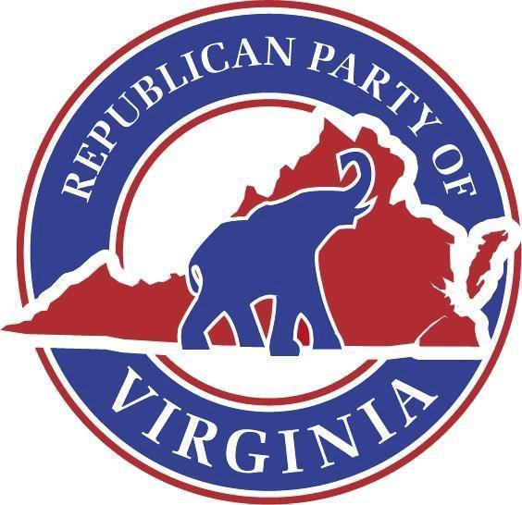

Republican Party of Virginia

[www.Virginia.GOP](http://www.virginia.gop/)

Official Call of the State Central Committee

*Issued March 17, 2025*

I, Richard L. Anderson, Chairman of the Republican Party of Virginia, do hereby call for a meeting of the State Central Committee on **Saturday, April 12th, at 11:00 am**. The meeting will occur at the Virginia Manufacturers’ Association, located at 2112 W Laburnum Ave # 205, Richmond, VA 23227.

The agenda shall be as follows:

1. Call to Order
2. Invocation
3. Pledge of Allegiance
4. Reading of the Republican Creed
5. Appointment of a Proxy Committee
6. Roll Call
7. Report of the Proxy Committee
8. Adoption of the Minutes
9. Auxiliary Reports
10. Chairman’s Report
11. New Business
    1. Election of RPV Chair
12. Benediction
13. Adjournment

The Richard D. Obenshain Center • 115 East Grace Street • Richmond, Virginia 23219   
 804-780-0111